Customer Shopping Analysis
1. Project Overview:
- Objective: This project analyzes customer shopping habits and transactional data to uncover valuable insights into spending patterns, product preferences, and customer behaviors.
- Scope: An end-to-end data analytics workflow covering data cleaning and exploration (Python), database querying (SQL), interactive dashboard creation (Power BI), and strategic business recommendations.
2. Dataset Summary:
- Dimensions: 3,900 rows and 20 columns.
- Key Attributes: Customer ID, Age, Gender, Item Purchased, Category, Purchase Amount ($), Location, Season, Review Rating, Subscription Status, Shipping Type, Payment Method, etc.
- Data Quality: Checked for missing values and consistency. Core transactional fields had zero missing values.
- Statistical Highlights:
- Average Purchase Amount: $59.76 (ranging from $20 to $100).
- Customer Age Range: 18 to 70 years (Mean: ~44 years).
- Average Review Rating: 3.75 out of 5.0.
3. Exploratory Data Analysis using Python:
We began with data preparation and cleaning in Python.
- Data Loading: Imported the dataset using pandas.
- Initial_Exploration: Used data.info() to check structure and data.describe() for summary statistics.
- Missing Data Handling: Checked for null values and imputed missing values in the Review Rating column using the median rating of each product category.
- Popular Products: High-volume items include Blouses, Jewelry, Pants, Shirts, and Dresses.
- Average Spend: Customers typically spend around $60 per transaction across categories.
- Features Engineering:
  - Created age_group column by binning customer ages.
  - Created purchase_frequency_days columns from purchase data.
- Database integration: Connected Python script to MySQL and located the cleaned DataFrame into the database for SQL analysis.
4. Data Analysis using SQL:
SQL queries were used to extract key business metrics from the database
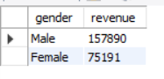
- Revenue by Gender – Compared total revenue generated by male vs. female customers.

- Discount vs. High Spend – Analyzed customers who used a discount but still spent more than the average purchase amount.
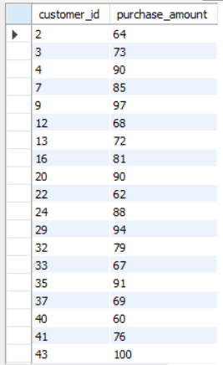

- Top Rated Products – Identified the top 5 products with the highest average review ratings.
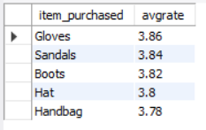

- Shipping Type Comparison – Compared the average purchase amounts between Standard and Express Shipping.
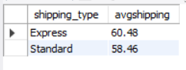

- Subscription Impact Analysis – Examined whether subscribed customers spend more by comparing average spend and total revenue between subscribers and non-subscribers.
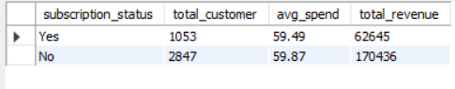

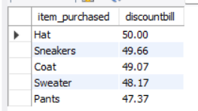
- Discount Utilization by Product – Identified the top 5 products with the highest percentage of purchases utilizing discounts.

- Customer Segmentation – Segmented customers into New, Returning, and Loyal based on their total number of previous purchases and counted each segment.
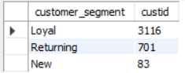

- Top Products by Category – Determined the top 3 most purchased products within each product category using window functions.
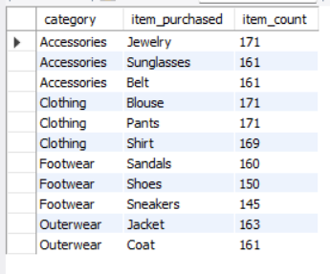

- Repeat Buyers & Subscriptions – Evaluated whether repeat buyers (more than 5 previous purchases) are more likely to subscribe.
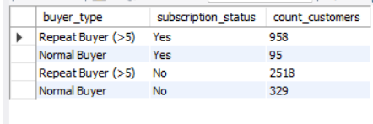

- Revenue by Age Group – Calculated the revenue contribution and average order value for each age demographic group.
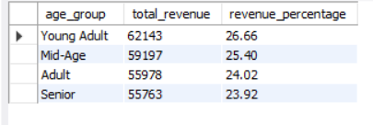

5. Dashboard in Power BI:
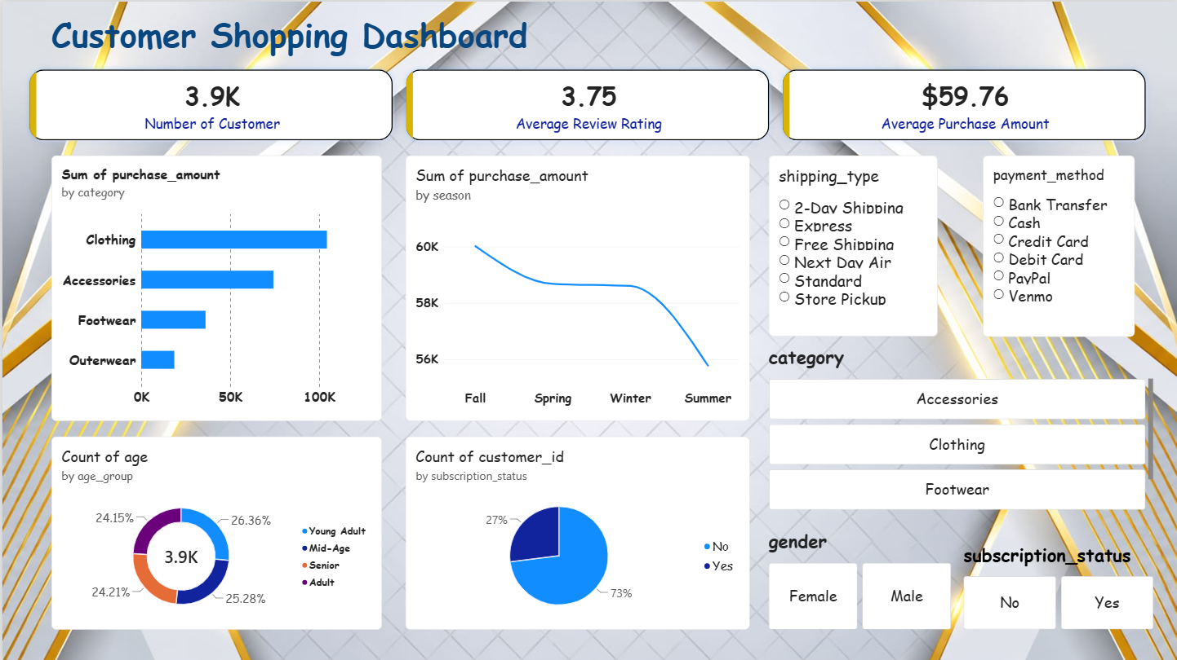
Finally, we built an interactive dashboard in Power BI to presents insights visuall.

6. Business Recommendations
- Boost Subscriptions: Introduce exclusive benefits and loyalty rewards to convert non-subscribers, as subscribers currently represent only ~27% of total orders.
- Inventory Focus: Prioritize inventory management for Clothing and Accessories, which drive the vast majority of total sales.f
- Payment & Shipping Flexibility: Maintain seamless support across all payment gateways (PayPal, Credit Card, Cash, Debit, Venmo) to reduce cart abandonment

